**Project Report Format**

**1. INTRODUCTION**

**1.1 Project Overview**

**1.2 Purpose**

**2. LITERATURE SURVEY**

**2.1 Existing problem**

**2.2 References**

**2.3 Problem Statement Definition**

**3. IDEATION & PROPOSED SOLUTION**

**3.1 Empathy Map Canvas**

**3.2 Ideation & Brainstorming**

**3.3 Proposed Solution**

**3.4 Problem Solution fit**

**4. REQUIREMENT ANALYSIS**

**4.1 Functional requirement**

**4.2 Non-Functional requirements**

**5. PROJECT DESIGN**

**5.1 Data Flow Diagrams**

**5.2 Solution & Technical Architecture**

**5.3 User Stories**

**6. PROJECT PLANNING & SCHEDULING**

**6.1 Sprint Planning & Estimation**

**6.2 Sprint Delivery Schedule**

**6.3 Reports from JIRA**

**7. CODING & SOLUTIONING (Explain the features added in the project along with code)**

**7.1 Feature 1**

**7.2 Feature 2**

**7.3 Database Schema (if Applicable)**

**8. TESTING**

**8.1 Test Cases**

**8.2 User Acceptance Testing**

**9. RESULTS**

**9.1 Performance Metrics**

**10. ADVANTAGES & DISADVANTAGES**

**11. CONCLUSION**

**12. FUTURE SCOPE**

**13. APPENDIX**

**Source Code**

**GitHub & Project Demo Link**

1. **INTRODUCTION**
   1. **Project Overview**

* This project helps the industries in monitoring the emission of harmful gases
* In several areas, the gas sensors will be integrated to monitor the gas leakage
* If in any area gas leakage is detected the admins will be notified along with the location
* In the web application, admins can view the sensor parameters.
  1. **Purpose**

The advantage of this simple gas leak detector is its

simplicity and its ability to warn about the leakage of

the LPG gas [11]. This system uses IBM technique to

send alert massage to respective person if no one is

there in the house and then gas leaks occurs, IBM

module is there to send immediate messages to the

respective person regarding the gas leak [13]. The

main advantage of this system is that it off the

regulator knob of the cylinder automatically when

1. **LITERATURE SURVEY**

A number of reviews on the subject of gas leakage detection techniques were done in the past either as part of research papers/technical reports on a certain leak detection method and other gas related subjects.

* 1. **Existing problem**

.This project proposed the most common problem experienced in our day- to- day lives that is regarding GAS container going empty.

. y. We bring this paper to create awareness about the reducing weight of the gas in the container, and to place a gas order using IOT.

. The gas booking/order is being done with the help IOT and that the continuous weight measurement is done using a load cell which is interfaced with a Microcontroller (to compare with an ideal value).

. When it comes it to security of the kit as well as gas container we have an MQ-2(gas sensor), LM 35(temperature sensor), which will detect the surrounding environment for any chance of error.

* 1. **References**

1. Pal-Stefan Murvay,Ioan Silea

'Journal of Loss Prevention in the Process Industries'-2012

2. Srinivasan, Leela, Jeyabharathi, Kirthika, Rajasree

“GAS LEAKAGE DETECTION AND CONTROL”Scientific Journal of Impact

Factor(SJIF): 3.134 March- 2014.

3. Prof.M.Amsaveni, A.Anurupa, R.S.AnuPreetha, C.Malarvizhi, M.Gunasekaran

“Gsm based LPG leakage detection and controlling system” the International Journal

of Engineering and Science (IJES) ISSN (e): 2319 – 1813 ISSN (p): 2319 – 1805 Pages

112-116 March- 2015'

4. V Suma, Ramya R Shekar, Kumar A Akshay 'Gas Leakage Detection Based on IOT'-2019

5. Adil Ahmad, Shaik Shaheeda.

Bengaluru Gas Leakage Detection Based System(ICEA2017).

6. Mohd Abid PG student Dept of VLSI Design and Embedded system.

VTU PG centre kalaburagi, India IJETER volume 6,issue 4,April (2018).

7. Kulothungan. S, Gukan. A , Arunprabu.K.B Associate Professor.

Student, IFET College of Engineering. IJEDR 2019

**2.3 Problem Statement Definition**

|  |  |  |  |  |  |
| --- | --- | --- | --- | --- | --- |
| **Problem statment**  **(ps)** | **I am (customer)** | **I am trying to** | **But** | **Becaus** | **Which makes me feel** |
| **PS-1** | **Industrialist** | **Monitor gas**  **Leakage in the industry** | **I don’t have any system for monitoring** | **The affordable of the system is high and the systems are sometimes making disasters** | **Unsafe** |
| **PS-2** | **Industrialist** | **Control the gas leakage** | **Also, the installation process is too complicated** | **The number of sensors is unpredictable and the positioning of equipment is improper** | **Disastrous** |

1. **IDEATION & PROPOSED SOLUTION**
   1. **Empathy Map Canvas**
2. 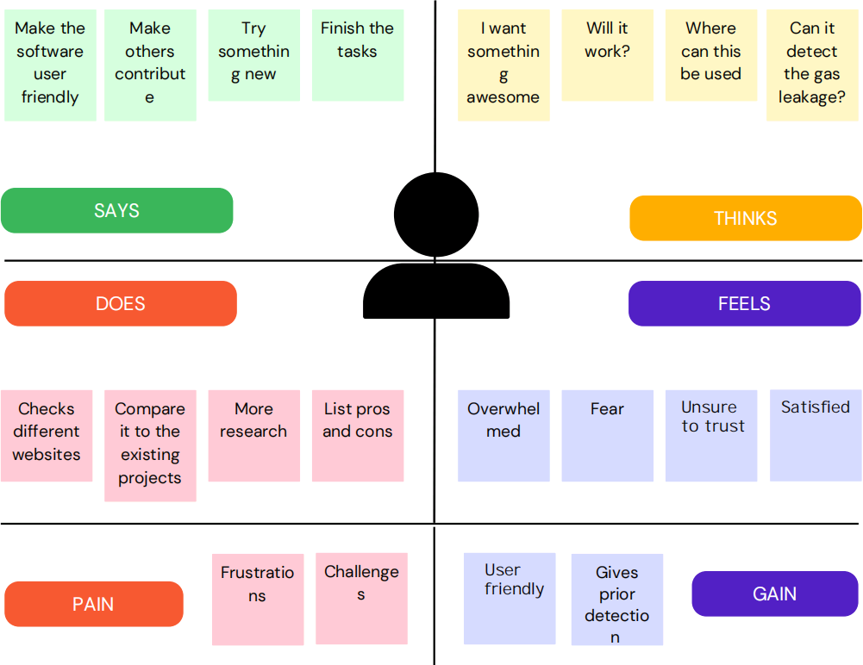

**3.2 Ideation & Brainstorming**

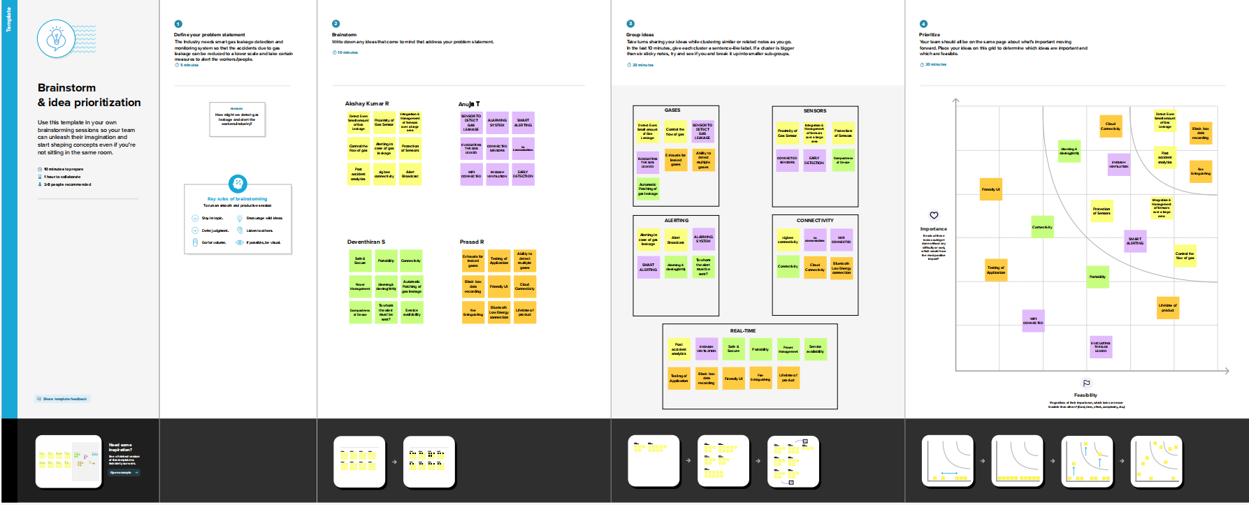

**3.3 Proposed Solution**

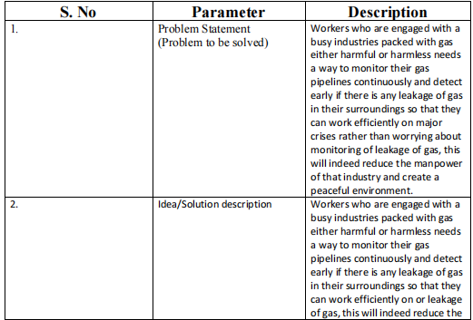

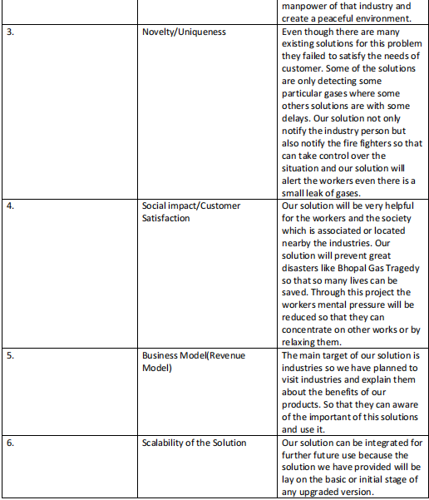

**3.4 Problem Solution fit**

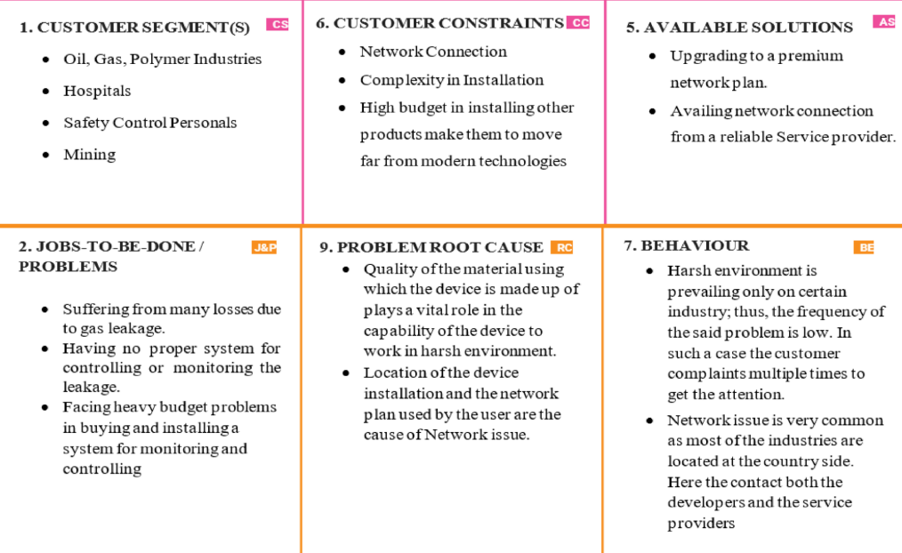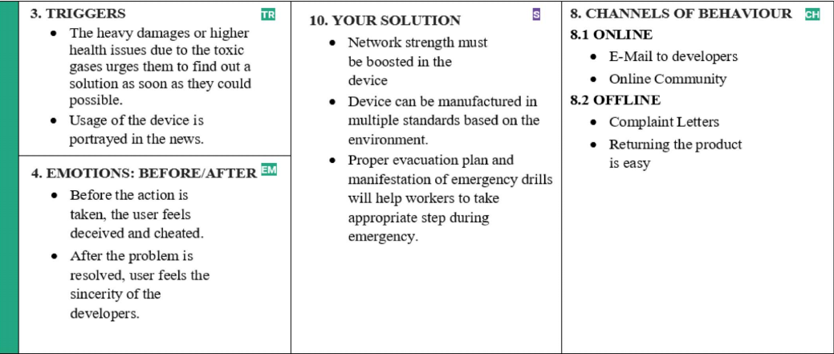

**4. REQUIREMENT ANALYSIS**

**4.1 Functional requirement**

**Following are the functional requirements of the proposed solution.**

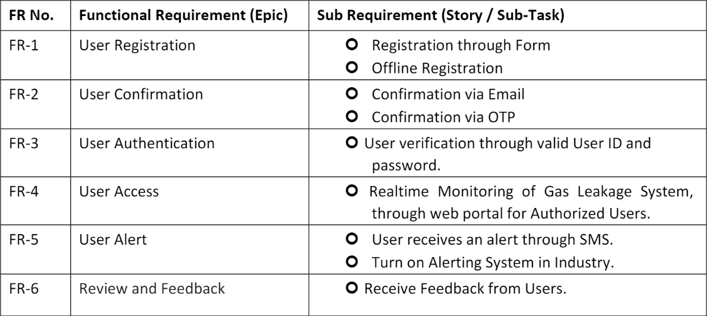

**4.2 Nonfunctional requirement**

**Following are the non-functional requirements of the proposed solution.**

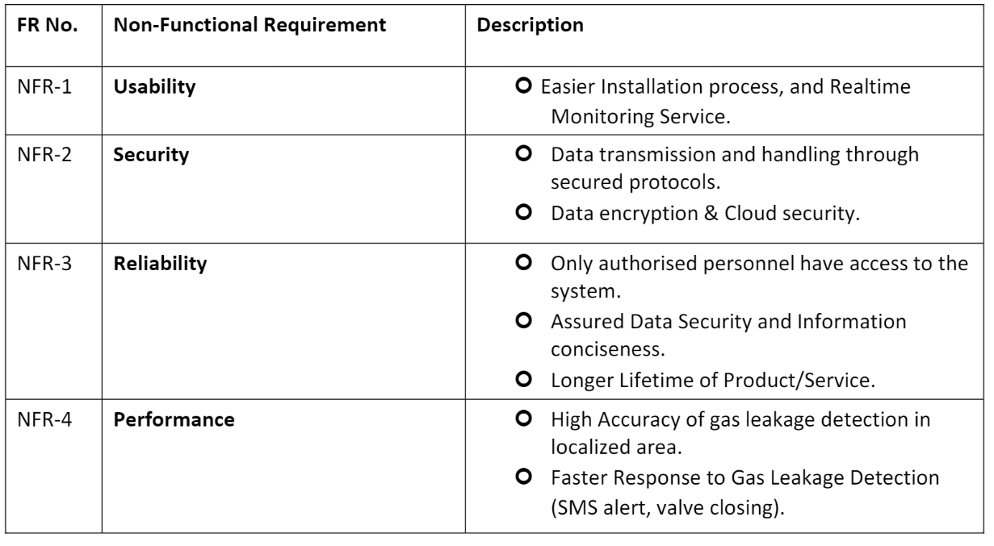

**5.PROJECT DESIGN**

**5.1 Data Flow Diagrams**

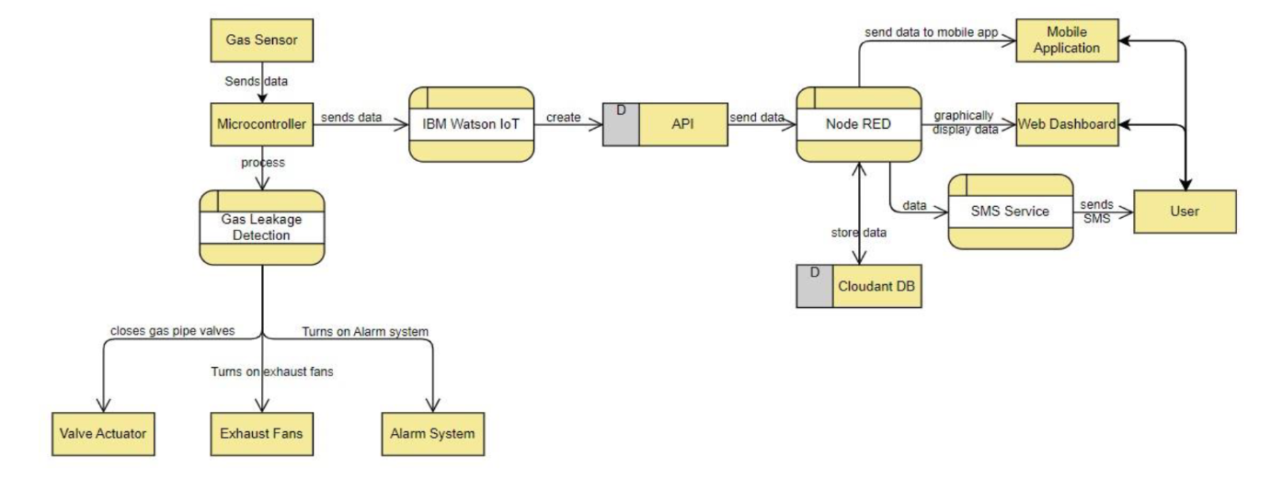

**5.2 Solution Architecture**

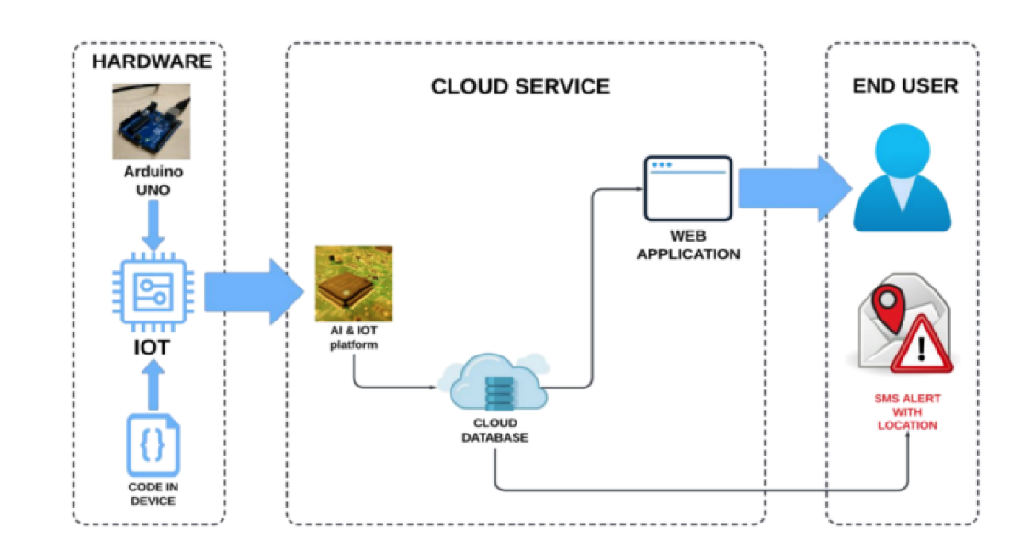

**Technical Architecture**

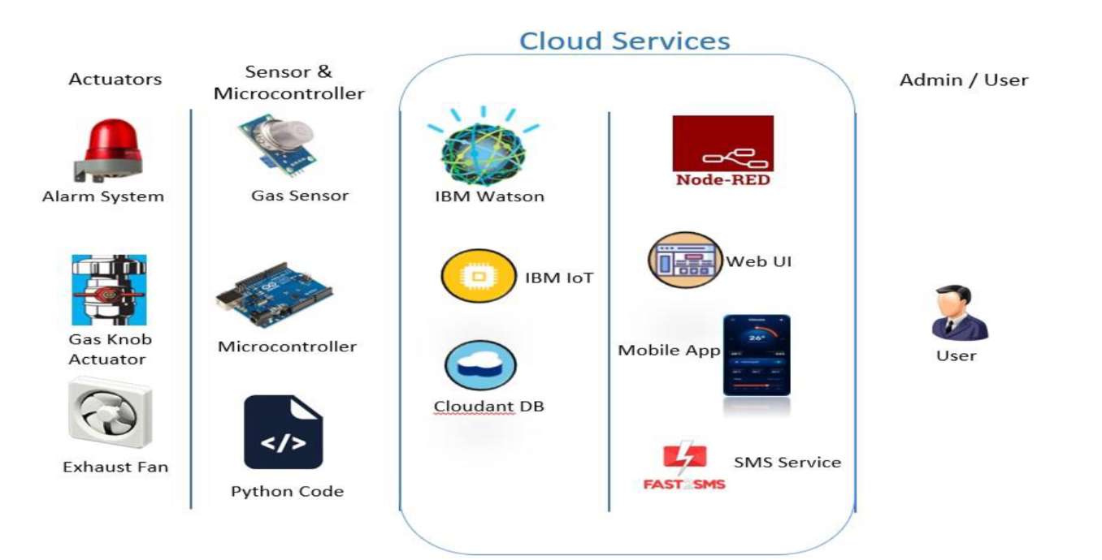

**5.3 User Stories**

**Problem Formulation:-**

Gas leakage is nothing but the leak of any gaseous molecule from a stove, or a pipeline, or cylinder etc. This can occur either purposefully or even unintendedly. As we are aware that these kinds of leaks are dangerous to our health, and when it becomes explosive it could cause great danger to the people, home, workplace, industry and the environment.

Few of the major incidents that took place due to gas leakage include the Bhopal Disaster and the Vizag Gasleak. The Bhopal disaster is known to be the worst industrial accident ever. Approximately 45 tons of Methyl Isocyanate was leaked from this insecticide plant. Methyl Isocyanate is an organic compound and a chemical that could come from the carbamate pesticides. This colorless, poisonous and flammable liquid is something that human beings have to be away from.

**List of Components :-**

|  |  |  |
| --- | --- | --- |
| **S. No** | **Name of the Component** | **Quantity** |
| **1** | LED | 2 |
| **2** | Resistor | 5 |
| **3** | Piezo | 1 |
| **4** | Gas Sensor | 1 |
| **5** | LCD 16*2 | 1 |

**LED :-**

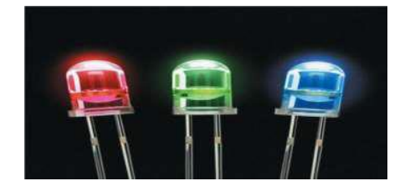

LED (Light Emitting Diode) is an optoelectronic device which works on the principle of electro-luminance. Electro-luminance is the property of the material to convert electrical energy into light energy and later it radiates this light energy. In the same way, the semiconductor in LED emits light under the influence of electric field. The symbol of LED is formed by merging the symbol of P-N Junction diode and outward arrows. These outward arrows symbolise the light radiated by the light emitting diode.

**Resistor :-**

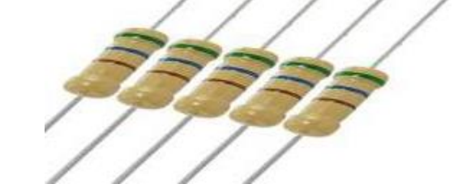

A passive electrical component with two terminals that are used for either limiting or regulating the flow of electric current in electrical circuits.

**Piezo :-**

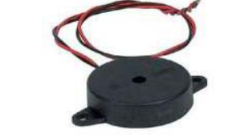

A piezo is a device that generates a voltage when force is applied or becomes deformed when voltage is supplied.

**Gas Sensor :-**

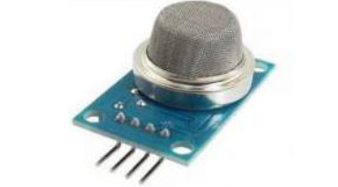

A gas sensor is a device which detects the presence or concentration of gases in the atmosphere. Based on the concentration of the gas the sensor produces a corresponding potential difference by changing the resistance of the material inside the sensor, which can be measured as output voltage. Based on this voltage value the type and concentration of the gas can be estimated.

**LCD 16*2 :-**

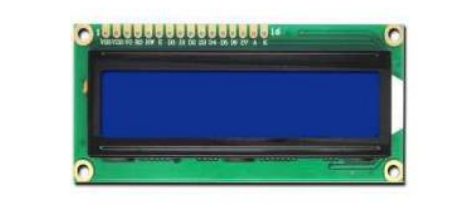

16×2 LCD is one kind of electronic device used to display the message and data. The term LCD full form is Liquid Crystal Display. The display is named 16×2 LCD because it has 16 Columns and 2 Rows. it can be displayed (16×2=32) 32 characters in total and each character will be made of 5×8 Pixel Dots. These displays are mainly based on multi-segment light emitting diodes. There are a lot of combinations of display available in the market like 8×1, 8×2, 10×2, 16×1, etc. but the 16×2 LCD is widely used. These LCD modules are low cost, and programmer-friendly, therefore, is used in various DIY circuits, devices, and embedded projects

**6. PROJECT PLANNING & SCHEDULING**

**6.1 Sprint Planning & Estimation**

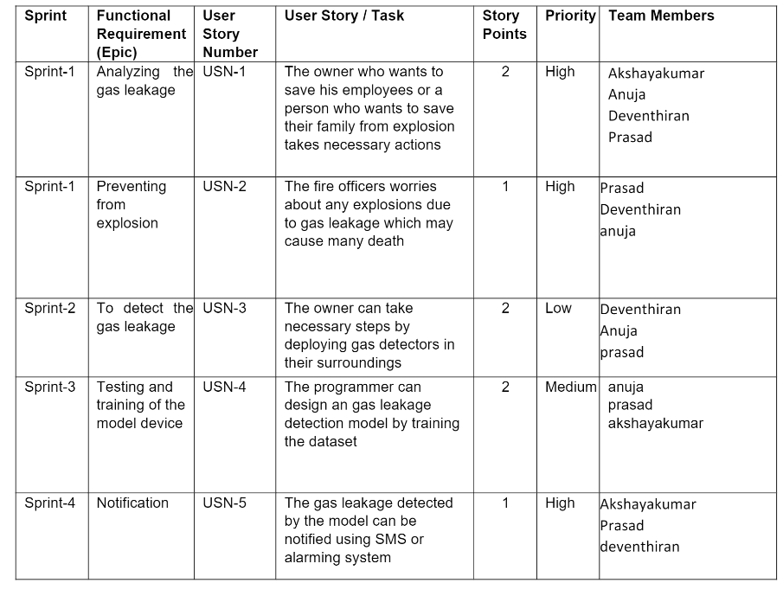

**6.2 Sprint Delivery Schedule**

|  |  |  |  |  |  |  |
| --- | --- | --- | --- | --- | --- | --- |
| **Sprint** | **Total Story Points** | **Duration** | **Sprint Start Date** | **Sprint End Date (Planned)** | **Story Points Completed (as on Planned End Date)** | **Sprint Release Date (Actual)** |
| Sprint-1 | 20 | 6 Days | 24 Oct 2022 | 29 Oct 2022 | 20 | 29 Oct 2022 |
| Sprint-2 | 20 | 6 Days | 31 Oct 2022 | 31 Oct 2022 | 20 | 05 Nov 2022 |
| Sprint-3 | 20 | 6 Days | 07 Nov 2022 | 12 Nov 2022 | 20 | 12 Nov 2022 |
| Sprint-4 | 20 | 6 Days | 14 Nov 2022 | 19 Nov 2022 | 20 | 19 Nov 2022 |

AV=**SPRINT DURATION/VELOCITY=20/10=2**

**7. SOLUTIONING & CODING**

**7.1 FEATURES**

**Feature 1:Detecting the Room temperature**

**Feature 2: Detecting the Gas**

**Feature 3:Home automation**

**CODES:-**

**PYTHON CODE TO IBM:**

#IBM Watson IOT Platform  
#pip install wiotp-sdk  
import wiotp.sdk.device  
import time  
import random  
myConfig = {  
    "identity": {  
        "orgId": "cwc5b7",  
        "typeId": "ak",  
        "deviceId":"ak_1"  
    },  
    "auth": {  
        "token": "731719106001"  
    }  
}  
  
def myCommandCallback(cmd):  
    print("Message received from IBM IoT Platform: %s" % cmd.data['command'])  
    m=cmd.data['command']  
  
client = wiotp.sdk.device.DeviceClient(config=myConfig, logHandlers=None)  
client.connect()  
  
while True:  
    temp=random.randint(-20,125)  
    hum=random.randint(0,100)  
    myData={'temperature':temp, 'humidity':hum}  
    client.publishEvent(eventId="status", msgFormat="json", data=myData, qos=0, onPublish=None)  
    print("Published data Successfully: %s", myData)  
    client.commandCallback = myCommandCallback  
    time.sleep(2)  
client.disconnect()

**NODE RED CODE**

**TEMPERATURE:**

msg.payload=msg.payload.”temp”return msg;

GAS:

msg.payload=msg.payload.”gas detector” return msg;

**8. TESTING:**

**a.TESTING:**

1.PYTHON CODE TO IBM

2.IoT SENSOR OUTPUT

3.IBM CLOUD TO NODE RED OUTPUT

**b. User Acceptance Testing**

**Purpose of Document**

The purpose of this document is to briefly explain th test coverage and open issues of the [product name] project at the time of the release to User acceptance testing(UAT).

**Defect Analysis**

**This report shows the number of resolved or closed bugs at each severity and hoe they where resolved .**

**9. RESULTS**

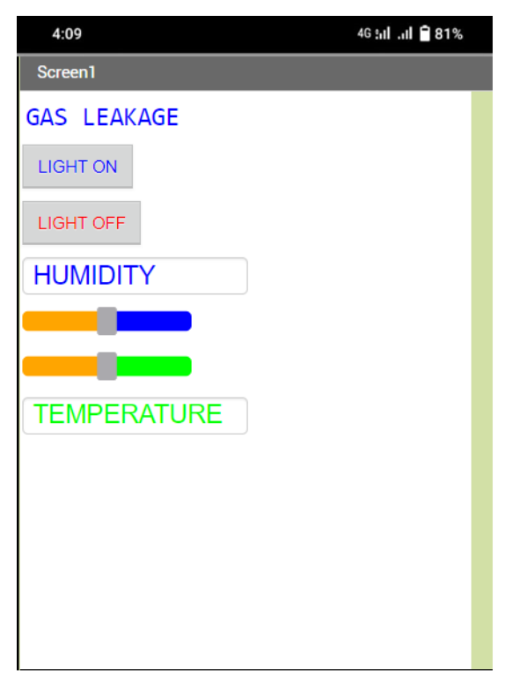

**10. ADVANTAGES**

• Because of the very narrow 0.3 nm line width of the laser emission, there is no interference from other gases.

• Response times are in the order 1 second. This allow for fine resolution/control when making process measurements.

• The intense laser light concentrated at the absorption wavelength enables path lengths up to 1 km to be measured.

• An average measurement is taken over the total path so that a narrow plume of gas has less chance of escaping detection.

• The range of measurement can be up to 4 orders of magnitude, enabling concentrations of 0.1 ppm to 1000 ppm to be measured.

• Because of the internal reference cell, the system is self calibrating.

**DISADVANTAGES**

• Only one gas can be measured with each instrument.

• When heavy dust, steam or fog blocks the laser beam, the system will not be able to take measurements. This is also the case when a person or vehicle blocks the path.

**11. CONCLUSION**

After this project performance, can conclude that detection of the LPG gas leakage is incredible in the project system.

Applicable usefully in the industrial and domestic purpose. In danger situations we are able to save the life by using this system.

An alert is indicated by the GSM module. A sensor node senses gas like CO2, oxygen, propane. The estimated range of transmission and consumption of power is obtained

The simple procedures and Arduino UNO Micro controller area used to build the sensor.

**12. FUTURE SCOPE**

With recent development in technology, Temperature display during periods wherein no message buffers are empty is one such theoretical improvement that is well possible. Another very interesting and significant improvement would be merge cloud with our device and to connect the user interface to create the mobile applications to alerting the functions.

**13. APPENDIX**

**Source Code**

**The source code has been uploaded in github. To refer the final source code click** ‘SOURCE CODE’

**GitHub & Project Demo Link**

## [IBM-Project-8003-1658905656](https://github.com/IBM-EPBL/IBM-Project-8003-1658905656)/[Final Deliverables](https://github.com/IBM-EPBL/IBM-Project-8003-1658905656/tree/main/Final%20Deliverables)/